****GREENWOOD PUBLIC SCHOOL, ADITYAPURAM**

**OUR MOTTO - DEVELOPMENT WITH DELIGHT**

**SYLLABUS FOR THE MONTH OF DECEMBER (2019-20)**

**CLASS-NURSERY**

|  |  |  |  |
| --- | --- | --- | --- |
| **SUBJECTS** |  | **ACTIVITY+USE OF ICT** | **PARENTS INVOLVEMENT** |
| **English** | **Oral(Rhymes) :** Jingle Bells , Ring –A - Ring –O-Roses , Jack and Jill  **Written** :Alphabets P,Q,R,S,T  **Workbook:** Page No. 22-27  **Recognition Alphabets:** A to N | C:\Users\123\Desktop\TC\cartoon-kids-with-abcdef-letters-vector-19913776.jpgC:\Users\123\Desktop\images\maxresdefault.jpg | Help your child in learning rhymes and written work |
| **Hindi** | **Oral : dfork,¡ &** छुट्टी ] डब्बू जी ] बिटिया रानी  **Written** : स्वर vks ls v% तक  **Recognition Alphabets:** स्वर अ ls v% तक  **Workbook:** Page no 22-29 | C:\Users\123\Desktop\images\hqdefault.jpg | dfork,sa ;kn djok,Wa rFkk o.kksaZ dh igpku fp=ksa +}kjk djok,W! |
| **Maths** | **Oral :** Counting 1-30  **Written**: 11-15  **Recognition Digit :**1-10  **Workbook:** Page no 22-27 | C:\Users\123\Desktop\images\maxresdefault (5).jpg | Motivate your child in learning tables. |
| **Drawing** | Page no 15-20 |  |  |
| **G.K.** | **Oral:** Festival names , My Super Heroes | PPT on Body parts and pet animals.  C:\Users\123\Desktop\images\pics-of-cartoon-fruits.jpg | Help your child to recog. the super Heroes. |
| **V.E.** | Help your friends | C:\Users\123\Desktop\images\school-building-md.pngPPT on School | Talk to your child about the school and your child’s friends. |
| **Physical Education** | Fun Games |  | Take your child to a park and play some games. |
| **Language Development** | Mom , Dad, Brother, Sister, Eat Drink, Water , Book, Close, Open ,Walk , Juice. |  |  |
| **Conversation** | **English Conversation**  **1. When do we celebrate Christmas ?**  Ans-25th December  **2. What is the colour of Santa Claus’s dress?**  Ans-Red  **3. When does the new year begin..**  Ans-1st January | **Hindi Conversation**  **प्रश्न 1- क्रिसमस कब मनाया जाता है ?**  **उत्तर - 25 दिसम्बर**  **प्रश्न 2-** **सैंटा क्लॉज़ के कपड़ो का रंग क्या होता है**  **उत्तर - लाल**  **प्रश्न 3-** **आपका पसन्दीदा फल कौन सा हैं**  **उत्तर** -  **आम** | Help your child in learning Conversation Que/Ans |

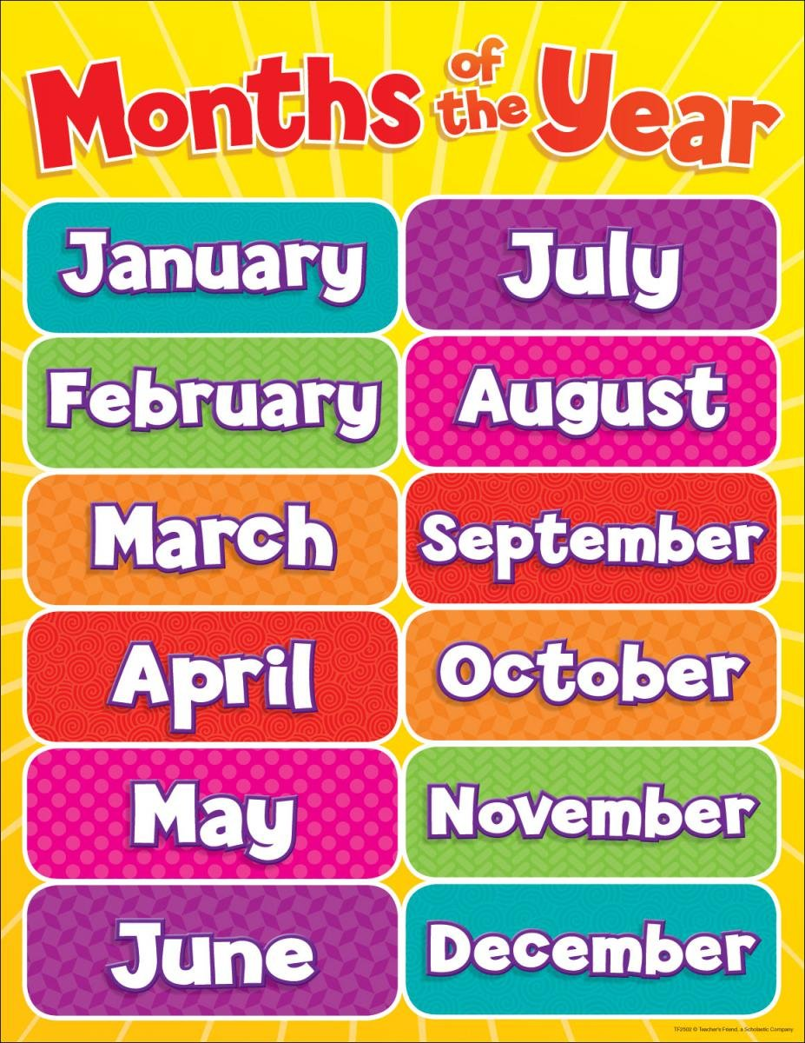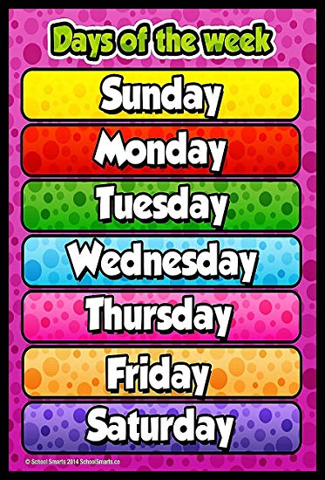

**Stars of November Month**

****

1. Aditya Gurjar

2. Prince Narwar

3.Rishav Singh

****GREENWOOD PUBLIC SCHOOL, ADITYAPURAM**

**OUR MOTTO - DEVELOPMENT WITH DELIGHT**

**SYLLABUS FOR THE MONTH OF DECEMBER (2019-20)**

**CLASS-L.K.G**

|  |  |  |  |
| --- | --- | --- | --- |
| **SUBJECTS** |  | **ACTIVITY+USE OF ICT** | **PARENTS INVOLVEMENT** |
| **English** | **Oral:-Rhymes-** Ten little fingers ,the alphabet song and revision of November month syllabus.  **Reading –** sounds of vowel “*e*” and “i” , use of a /an  **Written:** sounds of vowel “*e” and “i” ,* dictation use of a /an , revision of November month syllabus  **Vocabulary Building:** Animals , hospitals , school , bank , houses , birds | **C:\Users\123\Desktop\images\45092984-stock-vector-happy-school-kids-with-alphabet-blocks.jpg** | **Help your child in learning rhymes and written work** |
| **Hindi** | **मौखिक**: **कविताएँ – शिक्षा मेरी माँ , मेरा घर और दादा जी**  **पठन- पाठन**- व्यंजन वर्ण – क से ज्ञ तक का पुनः अभ्यास दो और तीन वर्णो से बने बिना मात्रा वाले शब्द !  **Written**: दो और तीन वर्णो से बने बिना मात्रा वाले शब्द ,  व्यंजन वर्ण - क से ज्ञ तक का पुनः अभ्यास , श्रुतलेख | **C:\Users\123\Desktop\images\images.jpg** | dfork,sa ;kndjok,WarFkko.kksaZ dh igpkufp=ksa +}kjkdjok,W! |
| **Maths** | **Oral :** Number names one to fifteen , counting 1-150 , table 2-4  **Activity:** (Unit-5 and 6)  **Written :**Counting 1- 150, Tables 2-4 , Number names one to fifteen , reverse counting from 50-1 , Dictation | **C:\Users\123\Desktop\images\download (1).jpg** | **Motivate your child in learning tables.** |
| **G.K. Oral** | Oral- Occasions and festivals work people do. | **C:\Users\123\Desktop\images\800px_COLOURBOX20120355.jpgC:\Users\123\Desktop\images\download (4).jpg** | **Tell your child about different festivals celebrated in India** |
| **Drawing** | Vegetables , Pencil mango and home (page no 12-15) |  |  |
| **V.E.** | Always speak the truth |  | **Motivate your child to speak the truth.** |
| **Physical Education** | Athletic Events |  | **Take your child for a nature walk.** |
| **Language Development** | Kitchen , bedroom , bathroom , living room , dining room , Terrace , Building Show Room. Stationary shop . optical shop. |  |  |
| **Conversation** | **English Conversation**  **Q.1 When do we celebrate Christmas?**  Ans- We celebrate Christmas on 25 December.  **Q.2 When do we celebrate New Year?**  **Ans-** We celebrate New year on 1st January of each year.  **Q.3 Why do we celebrate Christmas?**  Ans- Christmas is celebrated to mark the birth of Jesus Christ.  **Q.4** What is the colour of Santa’s dress?  Ans- Red  **Q.5 Where do the Christians worship?**  Ans-Christians worship in a Church. | **Hindi Conversation**  **प्र1: क्रिसमस किसका प्रमुख त्यौहार हैं ?**  **उत्तर** क्रिसमस ईसाइयों का प्रमुख त्यौहार हैं !  **प्र2: क्रिसमस कब मनाया जाता हैं ?**  **उत्तर** क्रिसमस 25 दिसम्बर को मनाया जाता हैं !  **प्र3: सांता क्लॉज़ इस दिन बच्चों को क्या बांटते हैं ?**  **उत्तर** सांता क्लॉज़ इस दिन बच्चों को उपहार बांटते हैं !  **प्र4: ईसाई प्रार्थना करने कहाँ जाते हैं ?**  **उत्तर** गिरजाघर  **प्र5: क्रिसमस क्यों मनाया जाता है ?**  **उत्तर** क्रिसमस ईसामसीह के जन्मदिन के लिए मनाते हैं ! | |

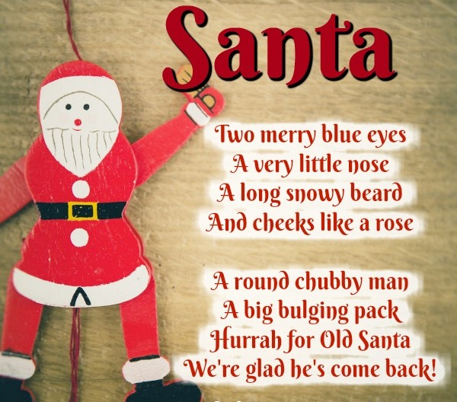

**Stars of November**

**Month (LKG-A)**

1. Vaishnavi Tomar

2. Puneeth Penta

3. Aryan Singh

4.Devansh Dwivedi

**Stars of November**

**Month (LKG-B)**

1. Anshika Bhadoriya

2. Girraj Singh Gurjar

3. Harshvardhan Sharma

****GREENWOOD PUBLIC SCHOOL, ADITYAPURAM**

**OUR MOTTO - DEVELOPMENT WITH DELIGHT**

**SYLLABUS FOR THE MONTH OF DECEMBER (2019-20)**

**CLASS-U.K.G**

|  |  |  |  |
| --- | --- | --- | --- |
| **SUBJECTS** |  | **ACTIVITY+USE OF ICT** | **PARENTS INVOLVEMENT** |
| **English** | **Oral:-Rhymes-** My red Balloon , A little bird and Noun.  **Reading –**Page no –  **Written:** Chapter – 32 to 35, Use of ‘I am and you are’ Use of “the” Use of “our and their” , Pronoun –His and Her.  Workbook – Page no – 28 to 31  **Vocabulary Building:** Exit ,empty , break , lake , fast , feel , angry , fly.. | **C:\Users\123\Desktop\images\45092984-stock-vector-happy-school-kids-with-alphabet-blocks.jpg** | **Help your child in learning rhymes and written work** |
| **Hindi** | **मौखिक**: **कविताएँ –** नन्हें तारे , मेरे दोस्त , पालतू व जंगली जानवरों के नाम !  **लिखित:** पाठ 15 से 17 Rkd v% ( : ) dh ek=k ] j jsQ ( ) , j insu ( ) की मात्रा , प्रश्नोंत्तर, खाली स्थान श्रुतलेख एवं सुलेख !  **अभ्यास पुस्तिका** - पेज न. से Rkd ! | **C:\Users\123\Desktop\images\images.jpg** | dfork,sa ;kndjok,WarFkko.kksaZ dh igpkufp=ksa +}kjkdjok,W! |
| **Maths** | **Oral :** Table of 8 and 9 , Numbers name 31-50  **Written :** Numbers name 71-80, table of 10 , reverse counting from 50-1 , Time and Multiplication. | **C:\Users\123\Desktop\images\download (1).jpg** | **Motivate your child in counting objects and learning tables.** |
| **E.V.S** | **Oral –** Parts of Body , Types of leaves and seasons.  **Written** – Chapter – 12 and 13 , Air and Water , weather , use of air and water , seasons . |  |  |
| **G.K. Oral** | **Oral**- seasons , Indoor and outdoor games | **C:\Users\123\Desktop\images\800px_COLOURBOX20120355.jpgC:\Users\123\Desktop\images\download (4).jpg** | **Play some indoor games with your child** |
| **Drawing** | Page no 21 to 24 |  |  |
| **Music / Dance** | Christmas Song |  |  |
| **V.E.** | Obey your elders |  |  |
| **Physical Education** | Athletic Events |  | **Take your child for a nature walk.** |
| **Language Development** | Play together , Take three meals in a day , Keep your surrounding clean , sit straight. |  |  |
| **Conversation** | **English Conversation**  **Q.1 When do we celebrate Christmas?**  Ans- We celebrate Christmas on 25 December.  **Q.2 When do we celebrate New Year?**  **Ans-** We celebrate New year on 1st January of each year.  **Q.3 Why do we celebrate Christmas?**  Ans- Christmas is celebrated to mark the birth of Jesus Christ.  **Q.4** What is the colour of Santa’s dress?  Ans- Red  **Q.5 Where do the Christians worship?**  Ans-Christians worship in a Church. | **Hindi Conversation**  **प्र1: क्रिसमस किसका प्रमुख त्यौहार हैं ?**  **उत्तर** क्रिसमस ईसाइयों का प्रमुख त्यौहार हैं !  **प्र2: क्रिसमस कब मनाया जाता हैं ?**  **उत्तर** क्रिसमस 25 दिसम्बर को मनाया जाता हैं !  **प्र3: सांता क्लॉज़ इस दिन बच्चों को क्या बांटते हैं ?**  **उत्तर** सांता क्लॉज़ इस दिन बच्चों को उपहार बांटते हैं !  **प्र4: ईसाई प्रार्थना करने कहाँ जाते हैं ?**  **उत्तर** गिरजाघर  **प्र5: क्रिसमस क्यों मनाया जाता है ?**  **उत्तर** क्रिसमस ईसामसीह के जन्मदिन के लिए मनाते हैं ! | |

****

**Stars of November**

**Month (UKG-B)**

1. Kirti Balmiki

2. Tanushka Pal

3. Aniruddh Gurjar

4.Vibhan Sharma

**Stars of November**

**Month (UKG-A)**

1. Aarav Rajak

2. Shivansh Sharma

3. Ritika Bhadouriya

4.Aaradhya Kushwah

**Stars of November**

**Month (UKG-C)**

1. Ramlakhan Singh

2. Hitesh Singh Bhadoriya

3. Deepak Mahor